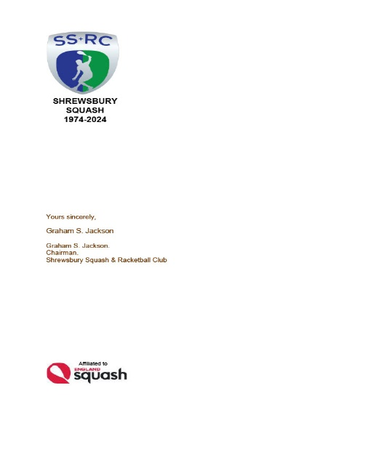

**2025 AGM Report 4th JUNE 1830 hours**

**SHREWSBURY SQUASH & RACKETBALL CLUB**

**PRESENT ::** Paul Allen; Annette Dickinson-Flint; Ted Eames; Dylan Ingman; Graham Jackson; Howard Jones; Pete Morgans; Gary Nolan; Lorna Rogers; Don Wallington. [10]

[11 in 2024] [13 in 2023] [13 in 2022] [12 in 2021] [12 in 2020] [17 in 2019] [18 in 2018] [16 in 2017] [13 in 2016] [12 in 2015].

**APOLOGIES** :: Mal Brown; Ian Dinwiddy; Keith Hansell; Max Lloyd; Lee Picken; Laura Mather; Cyril Nolan; Alex Whitehouse.

The Chairman welcomed everyone to the meeting and expressed his disappointment with the attendance.

There were no matters arising from the previous AGM minutes.

**CHAIRMAN AND SECRETARY’S REPORT**

There are a couple of additions to the initially issued Agenda and I will try to keep proceedings as brief as possible, but please initiate and actively take part in any discussions, after all, it is **YOUR AGM.**

You should all have a set of papers; it might seem like a lot of paper but it is in line with the Club policy of keeping everyone as informed as possible.

Included in the papers after the Agenda there are Copies of the minutes of last year’s AGM; please take a moment to read them. I will then take any matters arising from those minutes? There were none.

It’s a very difficult task to find the correct words to sum up a year of contrasts as simply and fairly as possible without missing someone or something so I apologise for any omissions, to summarize:-

The Club has had a further challenging year - for me, one of the highlights was the running of the second Chris Flint Bronze Tournament; despite great assistance from some Club Members, quite simply the event would not have happened without the tremendous hard work and impetus from Lee Picken and Ben Schur – an extremely hard act to follow if the Tournament is to continue in 2026 as it should.

In terms of membership generally, we have “lost” a number of old friends and members through ill health and retirement. We think particularly of Mal Brown and Cyril Nolan whose health issues have denied us the wisdom of their input into Club matters.

We have been fortunate in that we have attracted some new members which has been reflected in the makeup of our teams in the County Winter Leagues and the addition of a second Racketball Division.

On the National Over 50’s Racketball front currently we have 4 National Champions. Four Club members represented the County Over 50’s winning the National Counties Over 50’s Racketball Championships.  
Chris Morris and Chris Wase continue to win National and Regional Championships.

In terms of the Internal Leagues there has been an unfortunate reduction in Court Bookings. The average number of light meter transactions has dropped from an average of 596 per month to 569 – this equates to a reduction in income of £80 per month – this may not be sustainable in the longer term.

Clearly, we would like to see greater participation in our internal leagues and in County League Squash and Racketball matches. Every Club member should help to reverse this trend. Paul Allen offered to write a brief note for members outlining how playing in the Internal Leagues has improved his game and hence his enjoyment of the game.

The Club has maintained its support for the County Initiative to provide additional coaching for the junior girls by holding sessions organised by Ben Schur, assisted by Lee Picken on behalf of Shropshire County Council as part of the Club’s commitment to growing junior squash.

On behalf of the Club I wish to thank Cyril, Lee, Alex and Gary Nolan for their unstinting help, commitment and enthusiasm in providing additional afternoon coaching and development for promising and improving youngsters; we are delighted to see some of those youngsters entering the Internal Leagues. With an ageing membership the Club future depends upon our ability to encourage as many youngsters as possible; Gary, Patrick and Andy need our help in finding more volunteers.

The “Activity Space” continues to be an asset for a wide variety of uses in addition to the CF Tournament and is available to host a variety of Fitness related activities. Currently, Kevin Sandwith is unable to continue Circuits and Boxfit classes but we are fortunate to have excellent Yoga Classes run by Hannah Moselhi and the High Intensity training and Personal fitness classes run by the ubiquitous Mickey Brown.

We would like to see the Activity Space used more widely for Club Members and non-members so we need ideas and help from anyone who may wish to run any fitness related activity which will increase the promotion and availability of this facility. Please share any information you may have to help us achieve this aim.

There are, of course, other members to thank; in many ways it’s a dichotomy of extremes; there have been incredible examples of “volunteering” across the board although I remain exasperated by the contrast between those who “put in” and those who “take out”.

I cannot mention everyone but first of all thanks go particularly to Lee Picken who has been superb as Club Captain; he has taken over many of the tasks done by lots of other people, including myself.

The reduced and smaller number of Officers and Committee members, particularly Treasurer Laura Mather, Membership Secretary Lorna Rogers, Cyril and Gary Nolan, Pete Morgans and the Team Captains, as well as Committee Members, have all kept the Club functioning and in a relatively good shape to go forward into the next Season.

Thanks to the stewardship of Laura, our Treasurer, the Club Accounts, whilst under strong pressure, have maintained a reserve and have remained relatively strong despite large increases in energy and housekeeping costs and an unfortunate drop in court light income.

This reserve has been essential in enabling the Club to deal with all the changes in energy costs and has so far protected members from increased membership and court fees and has enabled us to programme refurbishment of the Courts.

The Club is extremely grateful to Iain Painter who has once again unselfishly agreed to audit the Club Accounts.

Please bear in mind that the Club Accounts cover the year September 2023 to August 2024; therefore some significant expenditure on ”facilities” will not show in the accounts until the next AGM.

The Club has continued to invest in maintaining and improving facilities for members from the redecoration carried out by the Bailey/Jones combo to nearly all of the “off court areas”, Lee for dealing with shower “failures”, cleaning etc and picking up on live streaming hiccups.

Members are reminded that the Court refurbishment is programmed for 7th-12th July. The “MyCourts” system will be used to indicate times of Court Closures.

[The “Monitor” is not currently working and has been sent back to “MyCourts” for repairs; the cost of which is to be discussed with Miles Montelius]

**TREASURER’S REPORT**

Laura forwarded a written report highlighting income& expenditure under various headings and advised everyone that they covered the financial year ending in August 2024. [See copy attached to these minutes].

She was very pleased to report an unaudited operating surplus of approximately £5,000. [On that basis and despite the recent reduction in light income, Laura thought that the Annual Subscription and Light Meter fees could remain at current levels. Paul Allen queried the cost of £3,400 for balls and Pete Morgans was disappointed with the very small “surplus” in the cost of refreshments.

**MEMBERSHIP SECRETARY’S REPORT**

Lorna reported that the number of members at August 2023 was 216 and 197 at August 2024 [Current level at June 2025 – 197 in all membership categories].

The figures reflected the first year when England Squash dealt directly with members individually.

**CLUB CAPTAIN'S REPORT.**

Unfortunately, Lee Picken was unable to attend the meeting at the last minute.

Lee has provided a report to be added to these minutes. [See attached]

**COMPETITION ORGANISER’S REPORT**

Pete Morgans reported that he hoped to hold the Club championships over a weekend in late August or early September with the possibility of a “Masters” type Competition in October. Ideas and help please.

A brief discussion was unable to come to a conclusion and understand why so few of 160 Senior Members were interested in playing team Squash and Racketball and the knock on effect of reducing numbers in the Internal Leagues – especially Racketball.

**JUNIOR SECTION REPORT.**

Gary gave an enthusiastic, unscripted report on Junior numbers in the mid-week and Saturday sessions attended by a core of 12-16 committed players and was very pleased that 95% has entered the second Chris Flint Tournament. Additionally several juniors were now playing in the internal leagues.

Gary and Chris Wase outlined a proposal to invite Joel Makin [World No. 5] and Miles Jenkins to attend a “Workshop and Interaction Day” at the Club. This would need support from a number of sources, the Chris Flint Fund, Corporate Sponsorship, Entry fees, “pay to play sessions etc.

The idea was approved and permission granted to enquire what dates might be available and approval given to ring fence a budget of approximately £2,500.

Ideas of Sponsorship sources to any Committee Member please.

**ELECTION OF CLUB CAPTAIN.**

Our volunteer for this position is Lee Picken

**ELECTION OF 1st TEAM CAPTAIN.**

Pete Morgan’s volunteering was approved.

**ELECTION OF TREASURER**

Laura Mather’s volunteering was approved.

**ELECTION OF MEMBERSHIP SECRETARY**

Lorna Rogers volunteering was approved.

**ELECTION OF OFFICERS AND COMMITTEE.**

Nomination forms had been issued in advance of the meeting and the results are:-

Chairman Graham Jackson

Acting Secretary Graham Jackson

Honorary Treasurer Laura Mather

Membership Secretary Lorna Rogers.

Club Captain Lee Picken

Assistant Club Captain Vacant Vice Chairman Ian Dinwiddy

1st Team Captain Pete Morgans

Safeguarding Officer Gary Nolan

Internal League Organiser Don Wallington

Head Coach Courtney Downing

Website Editor Kacper Pagorek/Alex Nolan/GSJ

County Representative Vacant

Competitions Organiser Pete Morgans

Assistant Competitions Organiser Vacant What’s App Coordinator Vacant Junior Organiser/Coach Gary Nolan

Maintenance Officer/Advisor Vacant

Sponsorship Vacant

Honorary Auditor Iain Painter

Committee Members Mal Brown

[w/o portfolio] Annette Dickinson-Flint

Dylan Ingman

Howard Jones

Max Lloyd

Guy Scott [Corresponding]

The Chairman is to attempt to find people to take some of the vacant posts.

**ANY OTHER BUSINESS**

1. Don Wallington summoned up the feeling of the meeting in expressing disappointment with the participation in the Internal Leagues. In addition to the Committee it is in the interests of ALL the members to promote participation in the Internal Leagues.
2. A knowledgeable volunteer is needed to investigate the possibility of varying the time setting of the light meters to allow small amounts of “add on” time to help finish matches.
3. A working group or a volunteer is needed to examine the practicalities and problems of extending the Male Changing Room into the Entrance Hallway.
4. A knowledgeable volunteer is needed to investigate varying the operation of the off court light sensors to combat the possibility of leaving players “in darkness”.

The meeting concluded at 2000 hours